# Kaleidoscope

Requirements and Specification Document

2019-02-06, version 1.0

### PROJECT ABSTRACT

This software will provide an overlay to a user that will allow the user to organize an assortment of apps. When a specific combination of buttons is pressed, the overlay will pop up showing the apps that the user has configured. For example, a user could be gaming and then they press the combination of buttons, which would bring up an overlay containing a section for web browsing, music, etc.

### DOCUMENT REVISION HISTORY

**Rev. 1.0 2019-02-10: Initial Version**

### CUSTOMER

This software enables people who play video games to multitask more efficiently and effectively. Although it is meant to be used while playing video games, it can be used in other contexts if the user desired.

Our client and tester for this program is Aaron Chung, a person who plays hours of video games a day. Although he is not a professional video game player, he has been playing video games for about 16 years, and unlike some people who stick to a the same few genre of games, Aaron has played many types of games such as FPS’s (first person shooters), MOBA’s (multiplayer online battle arena), card games, platformers, etc. He has used other overlay’s before such as Overwolf, but disliked how it was only accessible for certain games. Because of his experience in different types of games and experiences with overlays, he can help us make an overlay that would be desirable for anyone as well as test for usability and efficiency while playing different types of games.

### COMPETITIVE LANDSCAPE

Competitors in this market include Overwolf, Discord and Steam. Overwolf allows users to have an in game overlay. This overlay only allows for one app to be open at a time. Discord is a software used for communication. When gaming, Discord provides a simple overlay showing communications activity. Discord’s overlay is very simple and interacts well will most video games, and requires no key combination to be pressed. Steam is a PC gaming vendor. When gaming through Steam, the user can press a combination of button to bring up an overlay containing messaging, game details, and a web browser.

1. **Overwolf**

* Strengths
  + Has an appstore to customize what can be used while in the overlay
  + Accessible when in the in-game menu
  + Bounded to specific games
  + Can customize apps, making them opaque
* Weaknesses
  + Can’t be accessed in certain games
  + Can only have one app open at a time
  + Can’t access the game while using the overlay
  + The apps are game specific

1. **Steam**

* Strengths
  + Can be opened at anytime with a combination of buttons [Shift] + [Tab]
* Weakness
  + Can’t change key combinations
  + Only has features specific to steam (chat, friends list, steam store)
  + Game isn’t playable

1. **Discord**

* Strengths
  + There’s a minimized version where you see who is talking in your voice chat where the game is still playable
  + There’s a bigger version where you can message people in Discord
* Weaknesses
  + The maximized version of the overlay takes up the whole screen while the game isn’t playable
  + Features only specific to Discord

### 

### USER REQUIREMENTS

The following are the key features required for the app.

1. **User opens the main application**
   1. The application will default to the last used preset (if no presets have been created, will default to a blank preset)
   2. **Adding Widgets to Preset: User selects ‘Add’ button**
      1. A pop-up will appear allowing the user to click and drag a widget into the preset preview window.
      2. Clicking off the pop-up will return user to the main screen.
   3. **Choose Background for Preset Preview: User selects “Game” Button**
      1. A pop-up window will appear allowing the user to select a game background or a generic desktop background to preview their preset on
         1. This allows the user to visualize how the overlay will appear while in game.
   4. **Preset Selection**
      1. Expandable side view will appear listing all of the presets the user has created.
      2. **Rename Preset**
         1. Double-clicking on a preset within the side view will allow the user to rename that preset.
      3. **New Preset: User selects ‘New’ Button**
         1. A Blank preset will appear in the preview section
         2. User will be prompted to name new preset.
      4. **Delete/Save Preset: User selects either ‘Delete’ or ‘Save’ Button**
         1. Save Button: When pressed the user will save the current preset
         2. Delete Button: When pressed the user will be prompted whether they are sure they want to delete the current preset.
      5. **Duplicate Preset: User selects the ‘Duplicate’ Button**
         1. User will be prompted to rename this copy of the preset
         2. A copy of the preset will be created and will be displayed on the preview window.

1. **Settings Section: User selects ‘Settings’ button**
   1. User can change resolution settings
   2. User can change opacity settings
   3. User can change grid settings
   4. User can change overlay shortcut settings
   5. User select back button to exit settings
2. **Use of Overlay: User presses a key combo to bring up overlay**
   1. User can press a key combo to select a widget from the overlay and interact with that widget
   2. User will be able to play in game while overlay is on the screen
   3. User can press the same key combo

### USE CASES

|  |  |
| --- | --- |
| Name | Select Game |
| Actor | Main App, User |
| Triggers | Game selected within app |
| Events | Bring up config for game |
| Exit Conditions | Save and exit |
| Post Conditions | Update save config, return to main screen |
| Acceptance Conditions | Upon restart, config changes persist, upon running game changes in effect |

|  |  |
| --- | --- |
| Name | Bring up overlay |
| Actor | Overlay, User |
| Triggers | Key combo |
| Events | User enters key combo to bring up overlay. Key combo can be set by user or is default seen in hot keys section of settings |
| Exit Conditions | Key combo |
| Post Conditions | Overlay is brought up |
| Acceptance Conditions | User should be able to enter a key combo corresponding to bringing up the overlay as described in hot keys section of settings and the overlay should appear on the screen after the key combo is entered. |

|  |  |
| --- | --- |
| Name | Close main app instance |
| Actor | Main app, User |
| Triggers | Right click in icon and exit, button selected |
| Events | Close all instances or processes related to app |
| Exit Conditions | App is closed |
| Post Conditions | none |
| Acceptance Conditions | When user selects button or right clicks icon and exits, all instances or processes are terminated |

|  |  |
| --- | --- |
| Name | Interact with widget |
| Actor | overlay |
| Triggers | Control click or other button combo on widget |
| Events | Varies possibly, expand or interact |
| Exit Conditions | Minimize button |
| Post Conditions | Back to game |
| Acceptance Conditions | Click widget, verify expand or interactable, minimize |

|  |  |
| --- | --- |
| Name | Add widgets |
| Actor | User and main app |
| Triggers | button |
| Events | Pop up with all widgets |
| Exit Conditions | Click on widget (outside of pop-up) |
| Post Conditions | Main app |
| Acceptance Conditions | Widget appear |

|  |  |
| --- | --- |
| Name | Hot keys |
| Actor | User and main app |
| Triggers | Button to record keys |
| Events | Record input |
| Exit Conditions | No keys pressed |
| Post Conditions | List button |
| Acceptance Conditions | Able to open and close overlay with hotkeys |

|  |  |
| --- | --- |
| Name | setting |
| Actor | User and main app |
| Triggers | button |
| Events | Settings screen |
| Exit Conditions | Back button |
| Post Conditions | Main app |
| Acceptance Conditions | Screen appears |

|  |  |
| --- | --- |
| Name | Removing widgets |
| Actor | User and main app |
| Triggers | Click and drag |
| Events | Trash bin icon appears |
| Exit Conditions | When you stop drop |
| Post Conditions | Main app |
| Acceptance Conditions | Widget disappears once dragged and stopped |

|  |  |
| --- | --- |
| Name | Resolution |
| Actor | User and main app |
| Triggers | Drop down box |
| Events | Click on arrow of box and list appears below the box |
| Exit Conditions | Selection of a Resolution or Click away from the drop-down |
| Post Conditions | Resolution displayed |
| Acceptance Conditions | When overlay opened, resolution is correct |

|  |  |
| --- | --- |
| Name | Opacity |
| Actor | User and main app |
| Triggers | A slider |
| Events | Screen showing opacity, number changes |
| Exit Conditions | Release slider |
| Post Conditions | Opacity display on side will display correct opacity |
| Acceptance Conditions | Correct Opacity is being displayed |

|  |  |
| --- | --- |
| Name | Grid |
| Actor | User and main app |
| Triggers | Radio buttons |
| Events | Picture with grid |
| Exit Conditions | Click |
| Post Conditions | Radio button selected |
| Acceptance Conditions | Grid view in main app |

|  |  |
| --- | --- |
| Name | Back Button (for Settings) |
| Actor | User and main app |
| Triggers | Clicking the button |
| Events | Takes you back to the main app |
| Exit Conditions | Back on the Main App |
| Post Conditions | Takes you back to the main app |
| Acceptance Conditions | Can see the main app screen and not the settings screen |

|  |  |
| --- | --- |
| Name | Close overlay |
| Actor | user |
| Triggers | Key combo |
| Events | Overlay disappears in game |
| Exit Conditions | Key combo |
| Post Conditions | Overlay is gone |
| Acceptance Conditions | Overlay is no longer on screen |

|  |  |
| --- | --- |
| Name | Open Presets List |
| Actor | User/Main App |
| Triggers | Button |
| Events | List of Presets will appear on the side of screen with a new preset button, save preset button, and remove preset button |
| Exit Conditions | Click on the Preset List button to minimize |
| Post Conditions | Preset List appears displaying correctly and disappears when pressed again |
| Acceptance Conditions | Able to view all existing presets as well as create,save, and remove presets |

|  |  |
| --- | --- |
| Name | Save preset overlay |
| Actor | Main App, User |
| Triggers | ‘Save’ button is selected |
| Events | Saves preset overlay |
| Exit Conditions | Preset overlay is successfully saved |
| Post Conditions | User can now exit main app and continue on saved preset overlay when reopening main app |
| Acceptance Conditions | User should be able to select ‘Save’ button once changes are made on a preset overlay. User should be able to load the same preset overlay in the last state it was in before the User saved the overlay. |

|  |  |
| --- | --- |
| Name | Load preset overlay |
| Actor | Main App, User |
| Triggers | ‘Load’ button is selected |
| Events | A pop up is shown with a list of saved preset overlays |
| Exit Conditions | Once the preset appears in the Main View |
| Post Conditions | Selected Preset is displayed within the Main View |
| Acceptance Conditions | Selected preset appears correctly in the Main View |

|  |  |
| --- | --- |
| Name | Create new preset overlay |
| Actor | User/Main App |
| Triggers | New Button Pressed |
| Events | A blank preset will display in the Main app and the user’s cursor will default to the naming section within the Preset Tab, prompting the user to select a name. |
| Exit Conditions | Once a name has been picked (“Enter” pressed) |
| Post Conditions | User will be able to customize a new Preset from scratch |
| Acceptance Conditions | A blank preset has appeared in the main view and a new save file has been created |

|  |  |
| --- | --- |
| Name | remove preset overlay |
| Actor | User/Main App |
| Triggers | Preset Selected and remove button pressed |
| Events | Preset will be deleted |
| Exit Conditions | Preset file deleted from local file system |
| Post Conditions | Next Preset on the list will be displayed in the main view, if no other presets a new one will be created or a default will be displayed. |
| Acceptance Conditions | No more data exists to relating to the previously select preset |

|  |  |
| --- | --- |
| Name | Duplicate preset overlay |
| Actor | Main App, User |
| Triggers | User clicks ‘duplicate’ button |
| Events | Adds a preset list item containing a copy of the preset overlay that was displayed when the user clicked the ‘duplicate’ button |
| Exit Conditions | New name is given for copy of preset |
| Post Conditions | New copy of preset will be displayed in the preview window |
| Acceptance Conditions | Copy of preset has been added to preset list in the side view |

|  |  |
| --- | --- |
| Name | Switch to different opened preset overlay |
| Actor | Main App, User |
| Triggers | Unselected preset list item selected |
| Events | User selects an unselected preset list item which contains a different opened preset overlay and that preset overlay is displayed on the main app |
| Exit Conditions | User successfully switches to a different opened preset overlay |
| Post Conditions | User now has access to a different opened preset overlay |
| Acceptance Conditions | Selected Preset is displayed correctly in the main view |

|  |  |
| --- | --- |
| Name | Rename Overlay |
| Actor | User/Main App |
| Triggers | Double Click on preset |
| Events | Ability to change the name of the currently selected preset. |
| Exit Conditions | Pressing “Enter” exits the renaming event |
| Post Conditions | New name will display in place of the old name for the current preset |
| Acceptance Conditions | Preset will be saved under the new name, and the old preset named will be removed from the system |

### USER INTERFACE REQUIREMENTS

This app will actually be split into two different interfaces. There will be a main application used for configuration but will otherwise run in the background. Then there will also be an overlay user interface that shall appear as configured by the main application.

For the main application, the goal is to provide the user the ability to configure an overlay. The user should be able to place widgets anywhere in the screen and to expand or shrink them to the size they desire. The user should also be able to save different configurations for each application they use the overlay in. For example, an overlay may be configured for each video game the user has on their system. The user should then be able to select the video game from the main app and launch it.

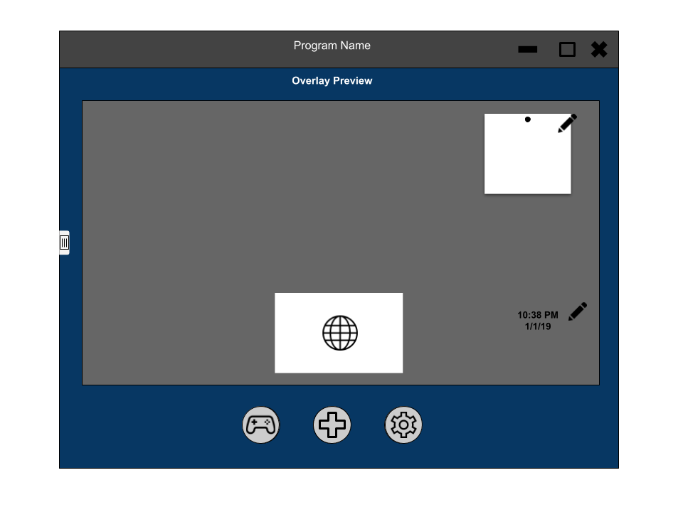

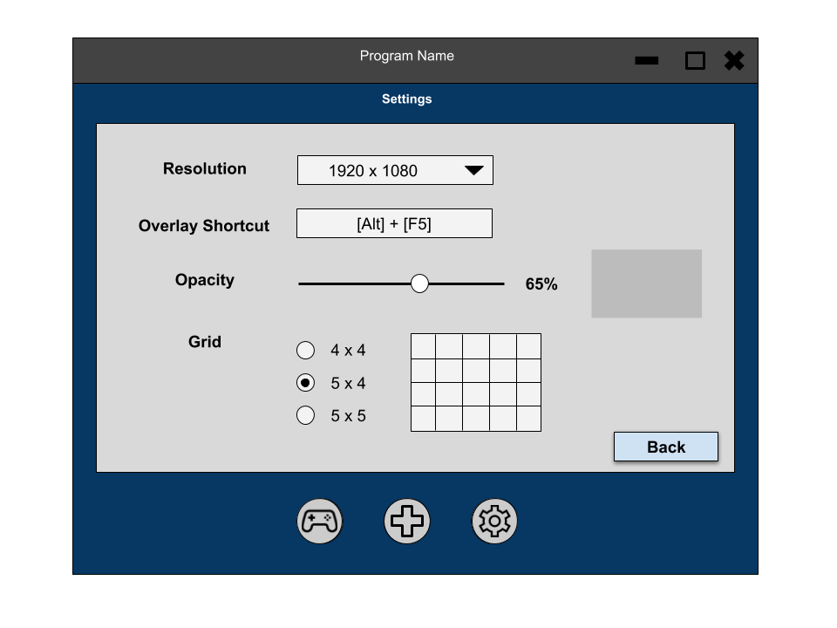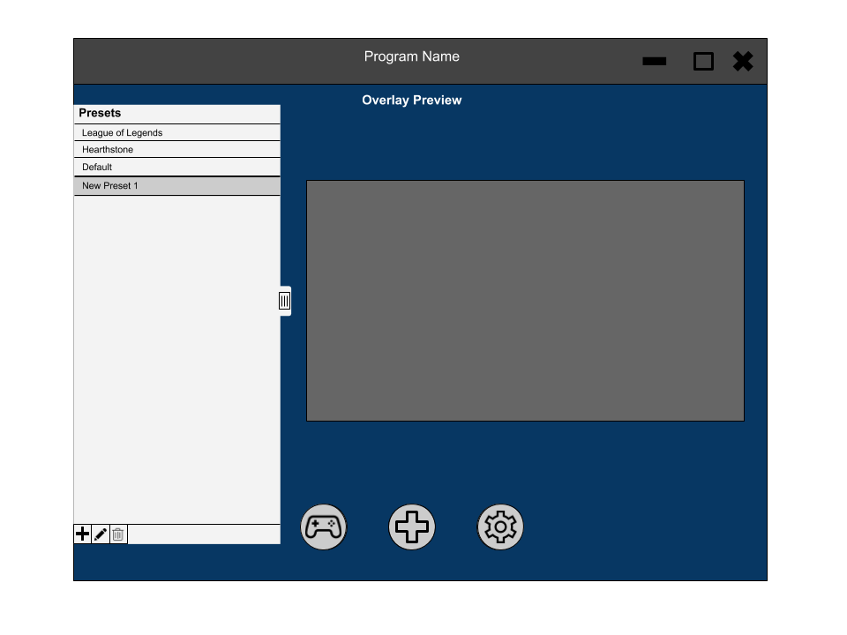

For the overlay interface, the user should be able to interact with their main screen in addition to interacting with widgets. If a user were playing a video game, for example, they should be able to play the game normally as well as clicking a Spotify widget to skip a song or to expand an email notification. These interactions should not take the user away from their main activity. Interactions may also expand the widget, such as clicking on a web browser.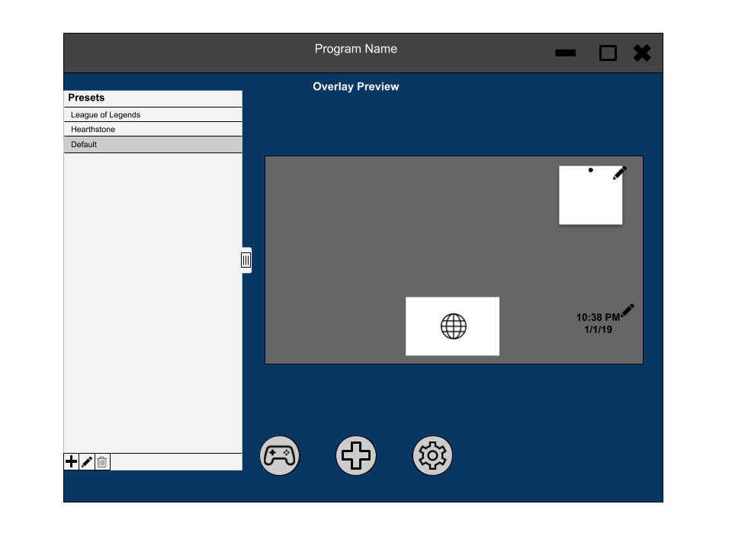

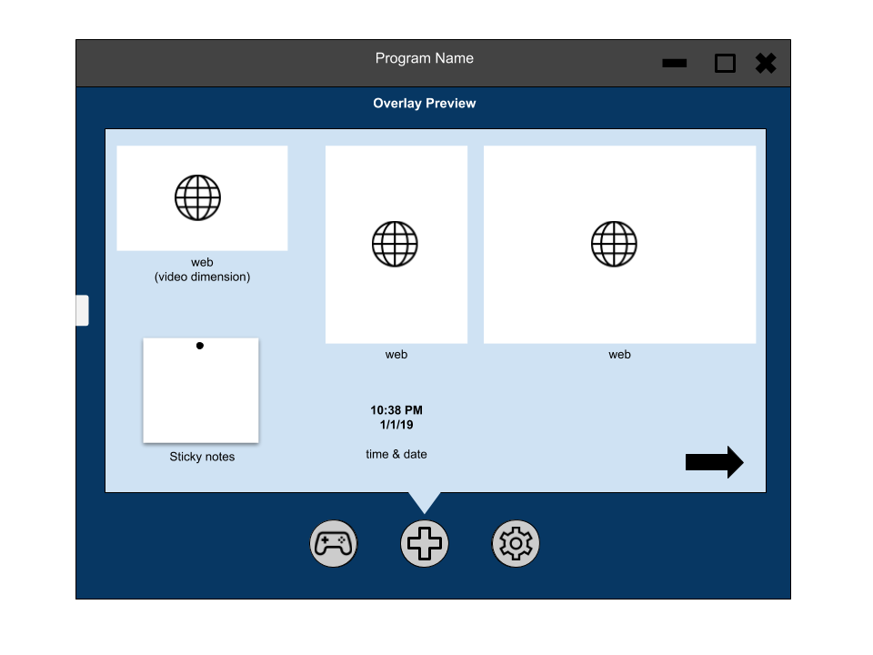

### SECURITY REQUIREMENTS

Preset data will be stored locally on the computer, therefore no user accounts will need to be made. No major privacy issues within our program due to any widget security issues from 3rd party apps being handled within its own main app. Permissions from any supported widgets will be needed as well as access to installing any needed apps (such as Spotify.) Permissions will be needed to allow our application to communicate with the computer’s operating system. Since our application will need to allow the user the ability to interact with the overlay and games at the same time, access/control over multiple processes will be required. Otherwise, no other security issues present themselves to us at this time.

### SYSTEM REQUIREMENTS

**Computer Requirements:**

Windows 10 (tentative) MacOS 10.14

4 GB RAM

Duo-Core CPU 2.0 GHz

2 GB of internal storage

**Software Requirements:**

Spotify

Chrome

YouTube

Our application will primarily require a laptop or desktop computer running the Windows 10 operating system. Memory and CPU usage are expected to be relatively low, so a computer with a modern duo-core processor (from at least 2010) and at least 4GB of RAM should be sufficient. Depending on whether external apps are incorporated as widgets or if they are pre-installed, the application will may require as much as a couple of GB of internal storage.

Requirements may vary, though, depending on other factors. Because one of the main purposes for the application is to multitask while gaming, higher performance hardware may be required. This application is not expected to add much of a performance strain to the computer, so a computer that is already running fine for these use cases should be able to handle the overlay.

Additional requirements include the apps that will be used as widgets in the overlay application. Supported apps include Spotify, Chrome, and YouTube. These apps will need to be installed to the system and may require user credentials.

### SPECIFICATION

